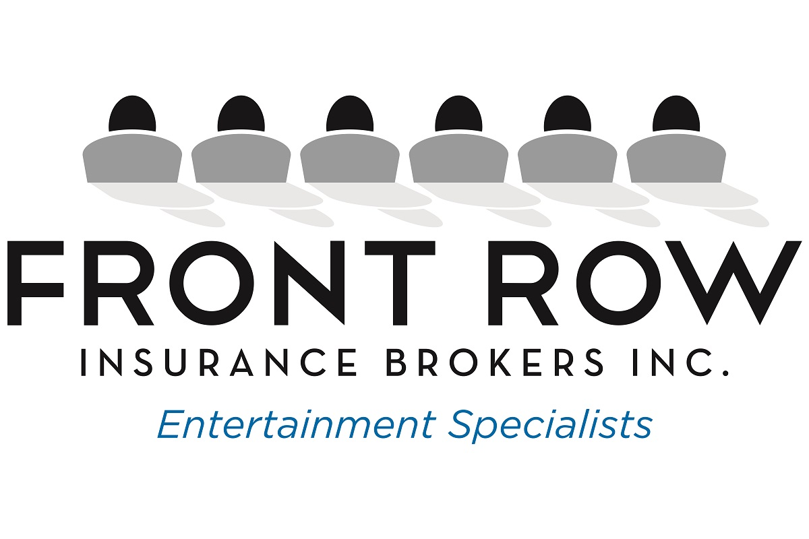
“Passionate about the arts. Better at insurance.”

Montreal Toronto Vancouver Los Angeles Nashville Paris New York

